the control expression has a start with the if statement here, and it terminates with our end if statement.

Both of our statements belong together. And every control structure we create will always have a start and an end.

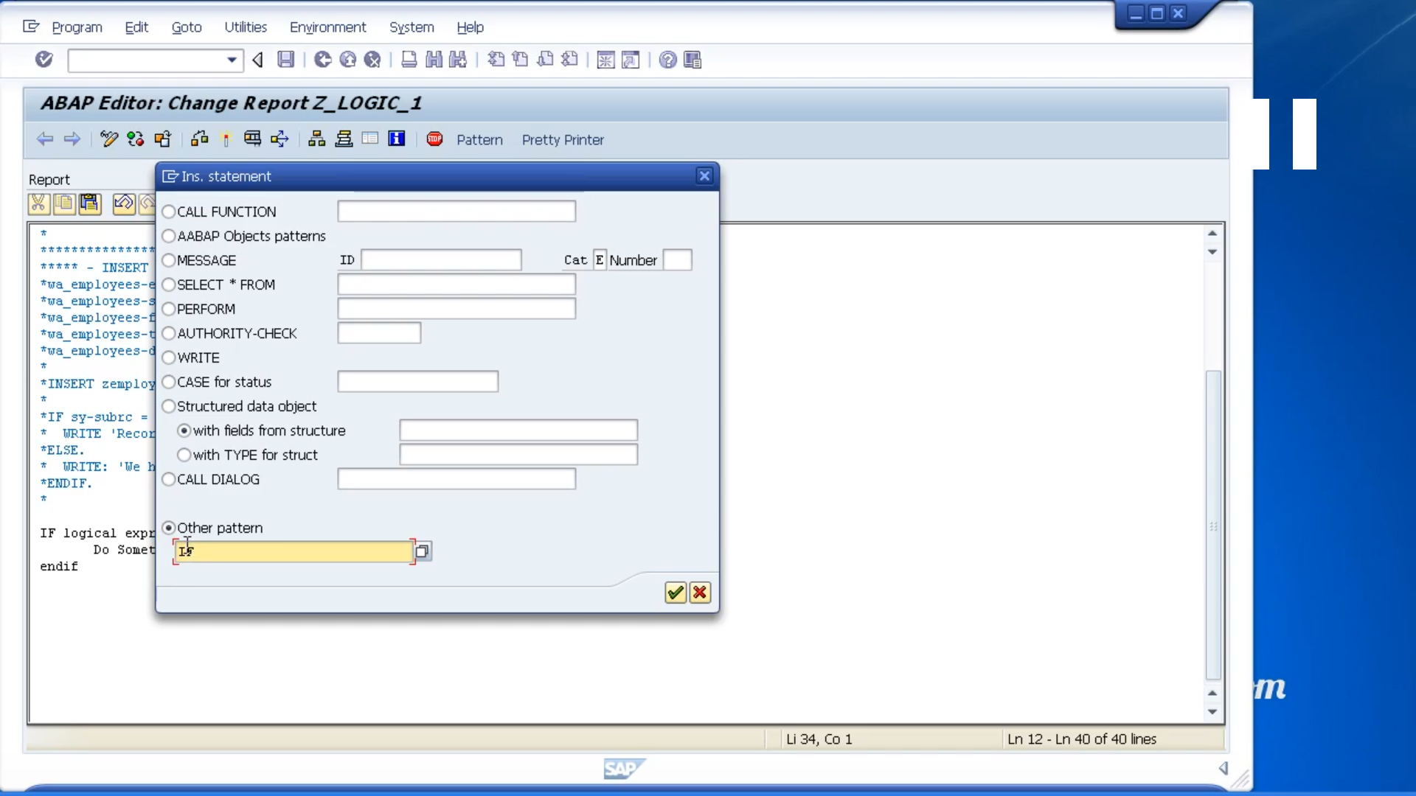

let's make use of the pattern tool. So, I'm going to click the Pattern button, Ctrl+F6, which brings up the insert statement dialogue box.

Now what I'm going to do is go down to the bottom where it says other pattern, and just put it in IF.

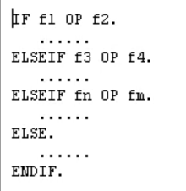

Now what this has done. It's brought back the structure of an if statement that we can follow as a guide so that,

